PIZZA MAX SALES ANALYSIS
SQL CODE & RESULTS

1. Executive KPIs
These will appear at the top of the Power BI dashboard:
- Total Sales
SELECT SUM(sales_amount) as total_sales from orders;
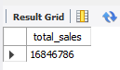

- Total Orders
SELECT COUNT(order_id) as Total_Orders from orders;
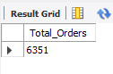

- Total Pizzas Sold
SELECT SUM(quantity) as Total_Pizzas_Sold from orders;
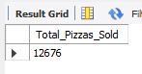

- Total Cost
SELECT SUM(quantity * unit_cost) as Total_Cost from orders;
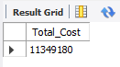

- Total Profit
SELECT SUM(sales_amount - (quantity * unit_cost)) as Total_Profit from orders;
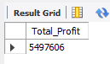

- Gross Profit Margin
SELECT CONCAT(ROUND(SUM(sales_amount - (quantity * unit_cost)) * 100 / SUM(sales_amount),2),'%') as Gross_Profit_Margin from orders;
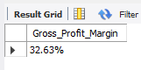

2. Monthly Sales & Profitability Analysis
SELECT
c.txn_year,
c.txn_month,
c.month_short_name,
SUM(o.sales_amount) AS sales_amount,
SUM(o.sales_amount - (o.quantity * o.unit_cost)) AS profit_amount
FROM orders o
JOIN calendar c
ON o.order_date = c.txn_date
GROUP BY
c.txn_year,
c.txn_month,
c.month_short_name
ORDER BY
c.txn_year,
c.txn_month;

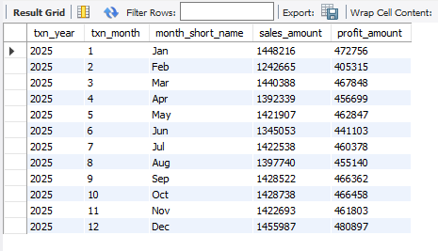

3. Product Wise Sales & Profitability Analysis
SELECT
p.pizza_id,
p.pizza_name,
SUM(o.quantity) AS total_quantity,
SUM(o.sales_amount) AS total_sales,
SUM(o.sales_amount - (o.quantity * o.unit_cost)) AS total_profit
FROM orders o
JOIN products p
ON o.pizza_id = p.pizza_id
GROUP BY
p.pizza_id,
p.pizza_name
ORDER BY
total_sales DESC

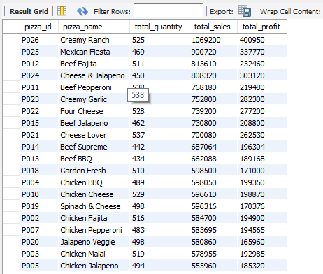

4. Product Size Wise Sales & Profitability Analysis
SELECT
o.size,
SUM(o.quantity) AS total_quantity,
SUM(o.sales_amount) AS total_sales,
SUM(o.sales_amount - (o.quantity * o.unit_cost)) AS total_profit
FROM orders o
GROUP BY
o.size
ORDER BY
total_sales DESC;

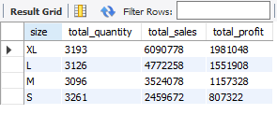

5. Branch Wise Sales & Profitability Analysis
SELECT
b.branch_id,
b.branch_name,
b.branch_location,
SUM(o.quantity) AS total_quantity,
SUM(o.sales_amount) AS total_sales,
SUM(o.sales_amount - (o.quantity * o.unit_cost)) AS total_profit
FROM orders o
JOIN branches b
ON o.branch_id = b.branch_id
GROUP BY
b.branch_id,
b.branch_name,
b.branch_location
ORDER BY
total_sales DESC;

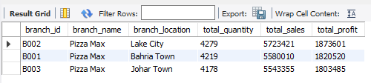

6. Order Type Sales & Profitability Analysis
SELECT
o.order_type,
COUNT(*) AS total_orders,
SUM(o.quantity) AS total_quantity,
SUM(o.sales_amount) AS total_sales,
SUM(o.sales_amount - (o.quantity * o.unit_cost)) AS total_profit
FROM orders o
GROUP BY
o.order_type
ORDER BY
total_sales DESC;

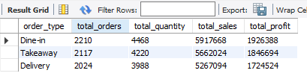

7. Payment Type Analysis
SELECT
o.payment_method,
COUNT(*) AS total_orders,
SUM(o.quantity) AS total_quantity,
SUM(o.sales_amount) AS total_sales,
SUM(o.sales_amount - (o.quantity * o.unit_cost)) AS total_profit
From orders o
GROUP BY
o.payment_method
ORDER BY
total_sales DESC;

